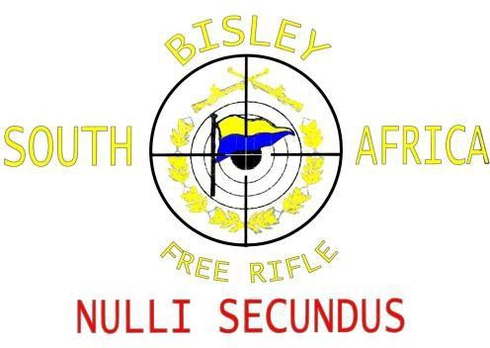
BISLEY FREE RIFLE CLUB

Of South Africa
A subsidiary of: The South African Bisley Union
Accreditation Number: 1300040

SABU LONG RANGE CHAMPIONSHIP
18 to 20 AUGUSTUS 2022

ARRANGEMENTS:
- Rules: | The competition is shot under the SABU rules.
- Format: | All individual matches will be shot shoulder-to-shoulder and in a single relay.
- Classes: | Entries from F-TR, F-Open and TR are welcome.
- Shooting Range: | General De Wet Shooting Range, Bloemfontein, Free State
- Blow-off: | 6h00 to 8h00 on the Alpha range each morning.
- Entries for individual practice: | Monday, Tuesday, Wednesday till 12h30: R250 per day.
- Entries for team only: | R250 per team member which did not enter for championship as below.
- Entries: | R1050 per shooter include the following,
 | - Team shoot (Wednesday)
 | - Individual shoot (Thursday, Friday and Saturday)
 | - No entries will be accepted without payment
 | - Entries close on 29 July 2022

Maximum number of entries = 108 shooters (“First-come-first-serve”)
- Gates: | Gate opening and closing times according to SANDF regulations and will be given through once entered for the competitions.
- Snacks and refreshments: | Will be available from Thursday to Saturday behind the fire point.
- Friday Evening Social event: | R100 for “Spitbraai” Buffet for the Friday evening.
- Range committee: | To be announced closer to the event.
Enter NOW to avoid disappointment!

PROGRAMME

Practice for Teams & Individuals:
Monday 15 August to Wednesday 17 August | Practice days on 700, 800 and 900m  Starting time: 08:00  Individuals will adapt to programmes of F Class team’s practice.
SABU LONG RANGE CHAMPIONSHIPS PROGRAM
Team Match:
Wednesday 17 August: | Starting time: 13:00  Team match (4 shooters and 1 coach/manager)  Teams made up by shooters themselves ahead of the event  Distances: 800m (2 + 15)  900m (2 + 15)
Individual Matches: Starting time for all individual days: 08:00
 | F-CLASS | TARGET RIFLE
Thursday 18 August: | Day 1 Distances: 700m (2 + 10)  800m (2 + 15)  900m (2 + 15)  900m (2 + 20) | Day 1 Distances: 700m (2 + 10)  800m (2 + 15)  900m (2 + 15)  900m (2 + 15)
Friday 19 August: | Day 2  Distances: 700m (2 + 10)  800m (2 + 15)  900m (2 + 15)  900m (2 + 20) | Day 2  Distances: 700m (2 + 10)  800m (2 + 15)  900m (2 + 15)  900m (2 + 15)
Saturday 20 August: | Day 3  Distances: 800m (2 + 15)  900m (2 + 20)  900m (2 + 20) | Day 3  Distances: 800m (2 + 15)  900m (2 + 15)  900m (2 + 15)
Prize giving on range after shoot

Medals: Teams overall: Only 1st Place (Gold medal) (F-Open, F-TR, TR)

Individual: Total of Day 1, Day 2, and Day 3 per distance
(Medals subject to 8 participants per class for 3 medals)

700m Total (Gold, silver & bronze medals) (F-Open, F-TR and TR)
800m Total (Gold, silver bronze medals) (F-Open, F-TR and TR)
900m Total (Gold, silver & bronze medals) (F-Open, F-TR and TR)
Each Day Total (Gold, silver & bronze medals) (F-Open, F-TR and TR)

Championship winners Floating Trophy Medal as well as (Gold, silver & bronze medals) (F-Open, F-TR and TR)

SABU LONG RANGE CHAMPIONSHIP 2022

ENTRY FORM
CLOSING DATE: 29 July 2022

Send entries to: Joe Deetlefs jdeetlefs@taupele.co.za

Name:
Surname:
ID / Passport number:
Country:
Province:
Club:
SABU Number:
Cell:
Email:
Class: | F-Open |  | F-TR |  | TR
Practice Individual Monday: | R250.00
Practice Individual Tuesday: | R250.00
Practice Individual Wednesday: | R250.00
Team shoot only: | R250.00
Championships: | R1050.00
Spitbraai buffet: | R100.00
Total Payment:

Payments to: Free State Bisley FNB
Account: 5507 3250 603
Branch code: 230137 Reference: LRC + SABU number/Surname

The SABU Long Range Championship will be hosted by Free State Bisley Union.

Enquiries: Joe Deetlefs +27 (0) 82 413 4952 or Koos Janse Van Rensburg +27 (0) 82 556 0446

